
How do you travel to school?
Green-Schools Travel
Tally Chart
Complete a travel tally ((IIII) with your class
Mode | Tally |  |  | Total |  | Mode |  |  |  | Tally |  |  | Total
Walk |  |  |  |  |  | Park & Stride
Bike |  |  |  |  |  | Carpool
Scooter |  |  |  |  |  | School Bus
Public Bus |  |  |  |  |  | Car
Bar Chart
Using the results from your tally, construct a bar graph
Mode | Each box represents ____ students
Walk
Bike
Scooter
Public Bus
Park & Stride
Carpool
School Bus
Car
Other
How many students took part in the survey?
What was the most popular mode of transport?

Class Survey
Class:
Date:


Conas a thaistil tú ar scoil?
Scoileanna Glasa: Taisteal
Cairt taifid
Comhlánaigh scóir taistil (IIII) le do rang
Modhanna taistil | taifid |  |  | Iomlán |  | Modhanna taistil |  |  |  | Taifid |  |  | Iomlán
Siúl |  |  |  |  |  | Páirceáil & Siúl
Rothar |  |  |  |  |  | Carr-Roinnt
Scút |  |  |  |  |  | Bus Scoile
Iompar Poiblí |  |  |  |  |  | Carr
Barrachairt
Bain úsáid as na torthaí agus tóg barraghraf
Modhanna taistil | Seasann gach bosca do ____ dalta
Siúl
Rothar
Scút
Iompar Poiblí
Páirceáil & Siúl
Carr-Roinnt
Bus Scoile
Carr
Eile
Cé mhéad mac léinn a ghlac páirt sa suirbhé?
Cad é an modh iompair ba mhó éileamh?

Suirbhé Ranga
Rang:
Dáta:

How do you travel to school?
School Survey
School:
Date:

This ‘hands-up’ survey aims to determine how students travel to school as part of your work on the travel theme. Repeat this survey in year 2 to determine if anything has changed.

Class |  |  |  |  |  |  | Total
Walk
Cycle
Park & Stride
Public Transport
Scooter
School Bus
Carpool
Car
Total

Which areas need work?

What actions could we take to improve?

Conas a thaistil tú ar scoil?
Suirbhé Scoile
Scoil:
Dáta:
Ranga |  |  |  |  |  |  | Total
Siúl
Rothar
Scút
Iompar Poiblí
Páirceáil & Siúl
Carr-Roinnt
Bus Scoile
Carr
Iomlán

Cé na réimsí oibre ar gá díriú orthu?

Cé na nithe is féidir a dhéanamh chun feabhas a chur ar an scéal?

How do you travel to school?
Comparing results
School:
Date:

Convert your survey results to percentiles and enter them into this table to compare the outcome. Analyse your results and enter your conclusions in the notes section.
For comparable results survey 1st – 5th in year 1 and 2nd -6th in year 2

Class | Year 1 | Year 2 | Difference
Survey Dates
Total Surveyed
Walk
Cycle
Park & Stride
Public Transport
Scooter
School Bus
Carpool
Car
Total

Notes :
Conas a thaistil tú ar scoil?
Class | Bliain 1 | Bliain 2 | Difríocht
Survey Dates
Total Surveyed
Siúl
Rothar
Scút
Iompar Poiblí
Páirceáil & Siúl
Carr-Roinnt
Bus Scoile
Carr
Iomlán
Comparáid a dhéanamh ar thorthaí

Scoil:
Dáta:

- Athraigh na torthaí ón suirbhé go peircintílí agus déan comparáid idir na torthaí ó bhliain 1 agus bliain 2
- Chun torthaí inchomparáide a fháil, déan suirbhé le do thoil ar an 1ú – 5ú háit i mbliain 1 agus 2 – 6 i mbliain 2

Nótaí:

Travel Survey (Week)
Green-Schools Travel
School:
Class:
Date:
Mode | Mon | Tues | Wed | Thurs | Fri | Total
Walk
Cycle
Park & Stride
Public Transport
Scooter
School Bus
Carpool
Green Total
Car
Total in class

Taisteal ar Scoil (Seachtain)
Scoileanna Glasa
Rang:
Dáta tosnu:
Modhanna taistil | Dé  Luain | Dé  Máirt | Dé  Céadaoin |  | Déardaoin | Dé  hAoine
Siúl
Rothar
Páirceáil & Siúl
Iompar Poiblí

Scút
Bus Scoile
Carr-Roinnt
Iomlán
(Taisteal Glas)
Carr

Méad sa rang
inniú​

Travel Action Day
Green-Schools Travel : Whole School Survey

School:
Date:
Class | 1st | 2nd | 3rd | 4th | 5th | 6th | Total
Walk
Cycle
Park & Stride
Public Transport
Scooter
School Bus
Carpool
Green Total
Car
Total in class
Green Travel %
Green Travel Total x100/Total in class

Which class had the highest % of students travelling green?

____________________________

Lá Gníomhaíochta
Scoileanna-Glas – Taisteal : Suirbhé-Scoil Iomlán
Scoil:
Dáta:

Rang | 1ú | 2ú | 3ú | 4ú | 5ú | 6ú | Iomlán
Siúl
Rothar
Scút
Iompar Poiblí
Páirceáil & Siúl
Carr-Roinnt
Bus Scoile
Iomlán (Glas)
Carr
Méad sa rang
inniú
Taisteal Glas %

Rang leis an líon is mó daltaí ag baint úsáid as taisteal glas?
_____
_____

Travel Action Day (Results)
Green-Schools Travel : Whole School Survey

School: | ________________
Date: | ________________
No. Students:

Mode of Transport |  | No | %
 | Walk
 | Cycle
 | Scoot
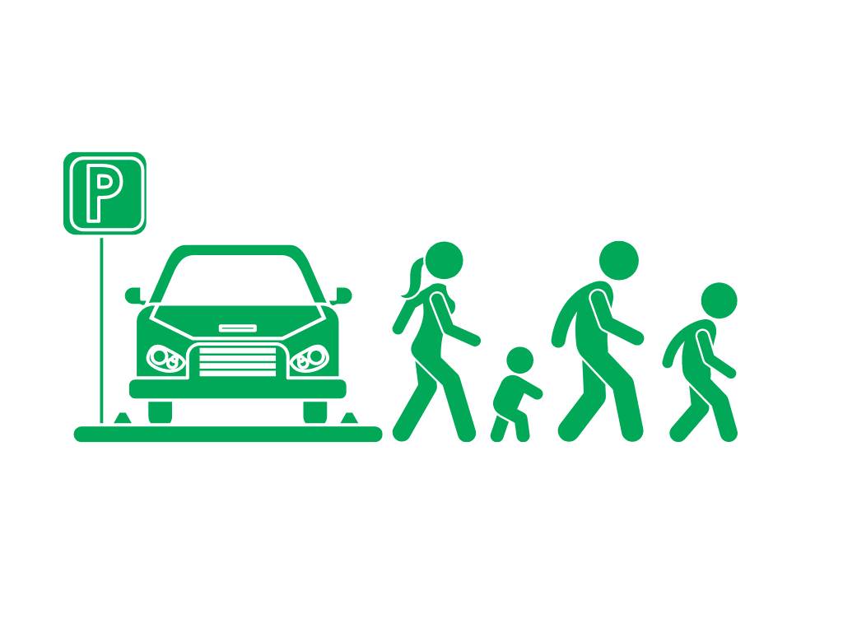 | Park & Stride
 | Carpool
 | School Bus
 | Public Bus
 | Car

____ students travelled in a ‘green’ way today

Thank you from the Green-Committee
Lá Gníomhaíochta (Torthaí)
Scoileanna-Glas – Taisteal : Suirbhé-Scoil Iomlán
Scoil:
Dáta:
Iomlán ( Daltaí i)

Modhanna taistil |  | %
 | Siúl
 | Rothar
 | Scút
 | Páirceáil & Siúl
 | Carr-Roinnt
 | Bus Scoile
 | Iompar Poiblí
 | Carr

% Daltaí ag baint úsáid as taisteal glas ______

Go raibh maith agat ón gCoiste Glas

