How to Start a Walking Bus Templates
Green-Schools Travel
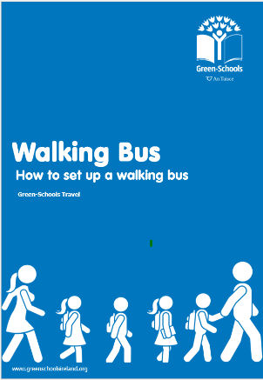
About
A set of template forms have been created to support schools in the establishment of a walking bus scheme. Please refer to our ‘Walking Bus – How to start a walking bus’ booklet available from our website www.greenschoolsireland.org for detailed information about starting a walking bus.

Starting your walking bus
- Organise an information session about starting a walking bus. A poster template and letter template is provided as a support
- At the information session, circulate the volunteer interest form to gather interest and identify possible routes
- Select your routes an conduct a route assessment with volunteers. Consider a mapping workshop to determine the most viable routes
- Determine how often your bus will operate, for example morning and evening or mornings only. Will it run every day or just some days?

Operating your walking bus
- Publish the walking bus route schedule on the noticeboard
- Invite parents to apply for their child to participate using the student application form
- Raise awareness about the walking bus by holding a colouring competition
- Walking buses are limited to a maximum of 18 participants and the minimum ratio is 2:6 adults to pupils. If your initiative proves popular you may have to create a ‘waiting list’.
- Successful applicants must sign the student contract to participate in the bus
- Edit the following forms to suit your agreed walking bus schedule. Two template variations are provided
  - Option 1: Walking Bus Volunteer Rota & Walking Bus Passenger Timetable
  - Option 2: Walking Bus Supervisor/Passenger Timetable (one sheet)
- Provide walking bus application forms for parents to apply for their child to participate
- Students must complete the ‘student contract’ prior to joining the bus (adjust to need)
- Organise a ‘pilot’ or training session and meet to discuss how it went


Enter School Name

Walking Bus
Information Session
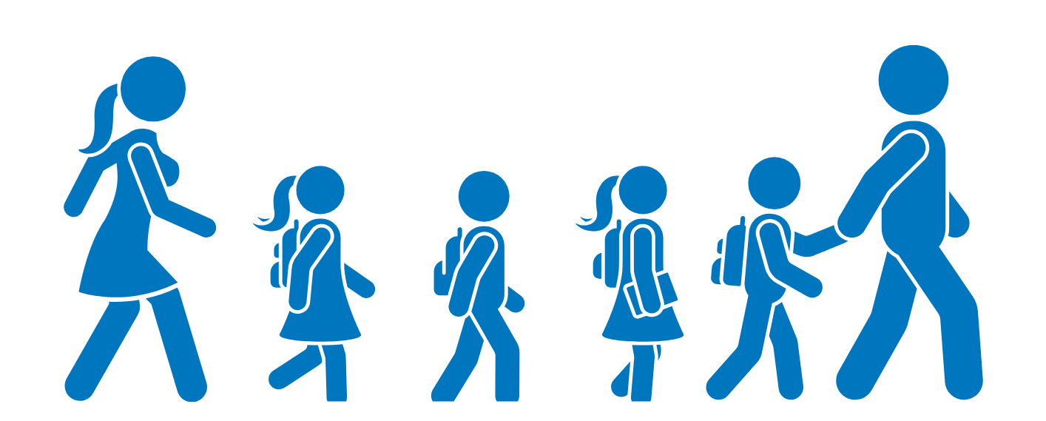

As part of our work on the Green-Schools Travel theme our school is hoping to organise a walking bus scheme. We will be holding an information session in our school

Date
Time

Introducing the Walking Bus Letter
Introducing the Walking Bus Initiative

Dear Parents / Guardians
In an effort to ease congestion around the school while also improving pupils’ fitness we are hoping to set up a ‘Walking Bus’ initiative in our school. The walking bus allows parents to share responsibility on the school run and enables young people to walk, who would otherwise be driven to school by car. This scheme can help to improve your child’s safety.
What is a walking bus?
A ‘Walking Bus’ is a term given to a group of school children who walk to and from school, supervised by volunteers (usually parents or guardians). As part of a walking bus, children walk to school as a group using an agreed route under the supervision of at least 2 responsible adults - a ‘driver’ and ‘conductor’. There are set ‘bus stops’ along the route where children and join the ‘bus’.
Where will the walking bus operate?
Routes will be established along those roads most used by our pupils, depending upon the level of interest shown by parents and their willingness to volunteer as drives and conductors. We will be holding an information session on ________________, please attend if interested in participating in this initiative.

Yours sincerely

Parents Association / BOM / Principal /

Walking Bus Volunteer Interest Form
Route

 |  | What days/times are you available to volunteer? |  |  |  |  |  | Notes
Volunteer Name | Contact Details | Time | Mon | Tues | Wed | Thurs | Fri | For example, are you related to students on this ‘bus’
 |  | Morning
 |  | Evening
 |  | Morning
 |  | Evening
 |  | Morning
 |  | Evening
 |  | Morning
 |  | Evening
 |  | Morning
 |  | Evening

Walking Bus Route Assessment
Is this route suitable for a walking bus initiative?
Observations
What safety precautions would you recommend?
School |  | Route :

It is important to check routes in advance to ensure that they are safe and suitable for a walking bus. If you are working on a Green-Schools Travel theme at present, contact your travel education officer for assistance. If your school is not working on a travel theme, you may wish to contact your local road safety officer for guidance.
Some things to look out for
- Are there pavements on the entire route that are wide enough for two children side by side
- Are they wide enough and well-maintained?
- Is it easy to cross the road?
- Do drivers give way to pedestrians
- Are walkers exposed to anti-social behaviour?
- Are there suitable places along the route for ‘bus stops.
- Are there hazards along the route that would impact student safety?
Draw a simple route map
Include potential bus stops, things to look out for…

Observations
Enter observations, are there any hazards? Can they be overcome?

Would you recommend this route for a walking bus initiative?
Discuss your observations as a group

Walking Bus Colouring in sheet
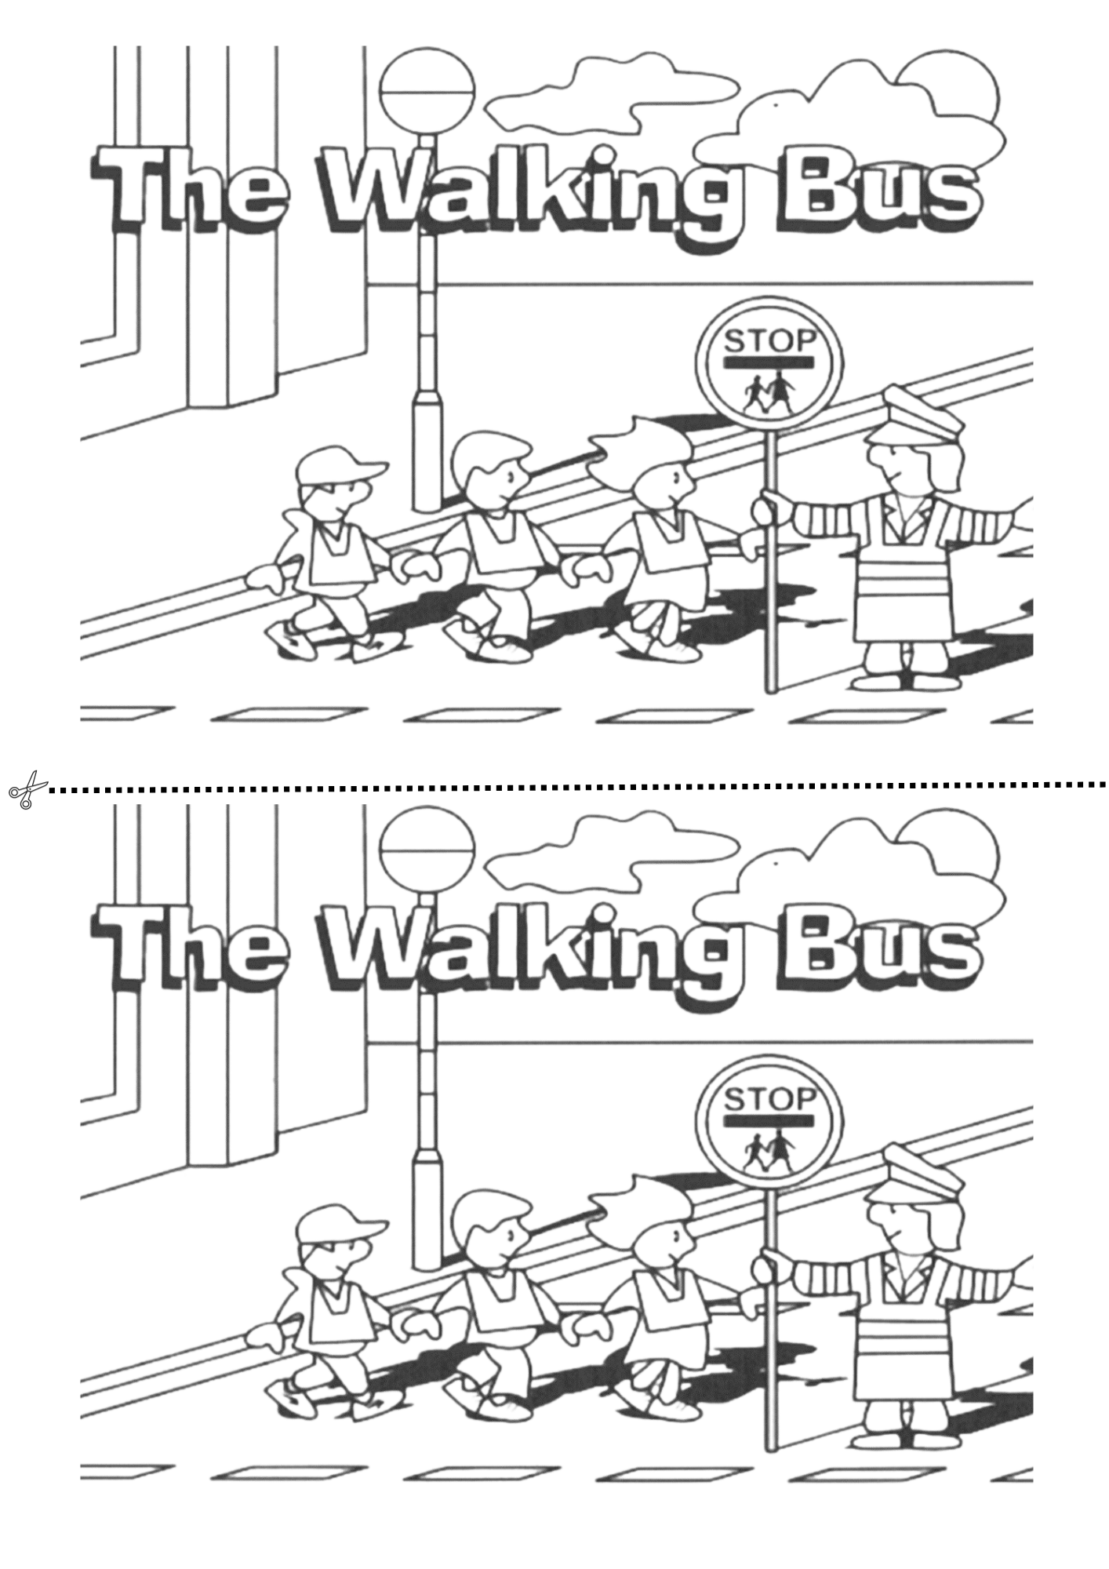

Student Application Form

If you would like to participate in the [Enter School Name] walking bus initiative,
Please complete this form and return to the walking bus coordinator
[Enter contact details of the appointed walking bus coordinator]
Contact Details:
Guardian Name | Address | Mobile | Emergency Contact Name | Emergency No.
Student Details:
Child’s Name | Age | Class | Allergies? | Any Medical Conditions?
Availability to help with walking bus:
Guardians of participating children are expected to volunteer when they can. Please indicate the days/times you are free to support the walking bus.
Morning only |  | Week on - Week off
Afternoon only |  | Day on - Day off
Afternoon at ____pm only |  | Other
Expectations of families availing of Walking Bus:
- To ensure children arrive in time for school, parents of both families are responsible that their child/children is ready for collection
- That no child is left unattended at any time, parent/guardian must be present to hand over and collect their child to and from driver and conductor
- If for any reason parents are unable to collect other children, advance notice must be given to all parties involved as early as possible
- All children are expected to behave appropriately whilst on a school walking bus

Student Contract

If you would like to take part in the ‘walking bus’ project you must read, understand
and agree to the following:

- You must follow all of the instructions from the ‘walking bus’ leaders
- You must wear the high visibility clothing provided
- You must walk sensibly and not cause a danger to yourself or others
- Any dangerous or inconsiderate behaviour by you will mean that permission for you to continue taking part in the ‘walking bus’ may be withdrawn
- You must take part in the ‘walking bus’ regularly or your place may be given to another pupil who wants to take part.

If you understand and agree to these rules, please sign this form and return it to the Walking Bus Coordinator
[Enter Walking Bus Coordinator Name]

Pupils Name : __________________________
Pupils Class: ___________________________

I have read the contract to join the ‘walking bus’
I understand and agree to these rules
I undertake that if I break these rules I may lose my place on the ‘Walking Bus’

Pupils Signature: ___________________ Date: ___________________

Student Contacts Card
School Name |  | Coordinator

A contacts card must be kept for every child using the bus so that guardians can be contacted if necessary. This is kept by the persons coordinating the bus scheme

Students Name | Class | Guardian | Pick up point (bus stop) | Telephone | Email | Emergency Contact No.

Walking Bus Volunteer Rota
Create a timetable for volunteers so everyone is aware of who is operating the walking bus. It is important to have at least
three volunteers per walking bus just in case one person cannot attend on a given day.
Route
Supervisor Timetable
Role | Monday | Tuesday | Wednesday | Thursday | Friday
Morning Driver | Enter Volunteer Name | Enter Volunteer Name | Enter Volunteer Name | Enter Volunteer Name | Enter Volunteer Name
Morning Conductor
Other
Afternoon Driver
Afternoon Conductor
Other

School Name |  | Walking Bus Route :

Walking Bus Passenger List

A record must be kept of passengers so that you know who will be using the bus and to make sure that no one is forgotten. The template provided below can be edited to reflect how your walking bus operates.

Morning Route | Bus Stop | Mon | Tues | Wed | Thurs | Fri
Example: Enter Students Name |  | Enter yes/no/Bus not operating | Enter yes/no/Bus not operating | Enter yes/no/Bus not operating | Enter yes/no/Bus not operating | Enter yes/no/Bus not operating

Supervisor Rota/Passenger List
Walking Bus Route : | Enter route/Bus Name

Supervisor Rota
Day |  |  | Mon |  |  |  | Tues |  | Wed |  | Thurs |  | Fri
Morning
Start Time:
Evening
Start Time:
Passenger List
Student Name |  | Bus Stop |  | Mon |  |  |  | Tues |  | Wed |  | Thurs |  | Fri
Enter students name |  | Enter |  | Enter Yes/No/Bus not operating |  |  |  | Enter Yes/No/Bus not operating |  | Enter Yes/No/Bus not operating |  | Enter Yes/No/Bus not operating |  | Enter Yes/No/Bus not operating

Walking Bus Schedule
Enter School Name
Route: | Enter Route Name
Walking Bus Lead (Driver) | Enter volunteer name
Walking Bus Conductor | Enter volunteer name
School Contact | Enter school coordinator name
Walking Bus Days | Enter days the walking bus will operate

Start Point | Time
Enter Start Location | Enter time
Enter Stop 1 | Enter time
Enter Stop 2 | Enter time
Enter Stop 3 | Enter time

Route: | Enter Route Name
Walking Bus Lead (Driver) | Enter volunteer name
Walking Bus Conductor | Enter volunteer name
School Contact | Enter school coordinator name
Walking Bus Days | Enter days the walking bus will operate

Start Point | Time
Enter Start Location | Enter time
Enter Stop 1 | Enter time
Enter Stop 2 | Enter time
Enter Stop 3 | Enter time

