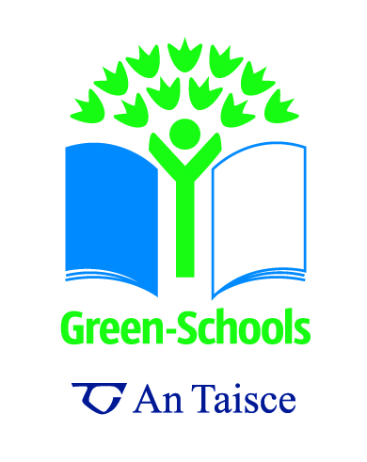 Waste Checklist
The following checklist is an open-ended checklist looking at the schools impact on the environment in relation to waste. This checklist also has an educational function whereby the process of gathering data raises awareness and gives you a basis for developing your action plan. Each question in the checklist can be answered ‘yes’ or ‘no’. ‘No’ indicates that improvement is possible. Quantifiable targets can then be set for area highlighted for improvement. The questions in the review below are suggested questions please feel free to add questions in order to examine a particular area relevant to your school.

Question | Yes/No | Action Notes: Waste
Prevention/Minimisation
Is there a purchasing policy for materials such as toilet tissues, stationery, books, notepaper, etc?
Does the school have email addresses/mobile phone numbers for families?
Does the school use notice boards/circulars to give out information to staff instead of individual bulletins?
Are students encouraged to avoid excess packaging with their lunches?
Are long life products chosen over short life ones?
Are materials bought in large packs to avoid excessive packaging?
Are copies/records saved electronically, not paper?
Is paper used on both sides?
Re-use/Recycle
Is re-useable selected first, then recyclable?
Are old envelopes saved for re-use?
Are casual notes written on scrap paper?
Is office waste paper recycled?
Does the school have or use any recycling facilities? If so what materials are recycled?
Does the school have a compost heap or compost bin?
Is the topic of waste and waste minimization incorporated into the school ethos/curriculum?

