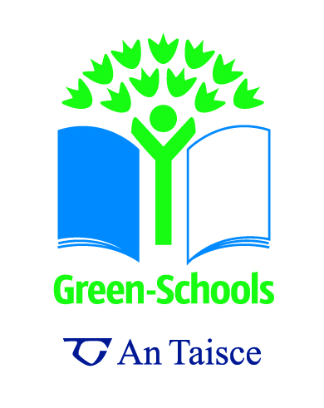

**Sample Awareness Questionnaire for Junior Classes**

1. **Do you know what 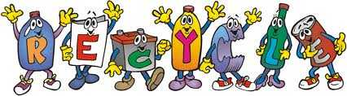 means?**

No = 

Yes = 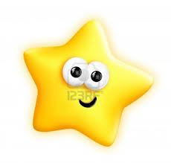

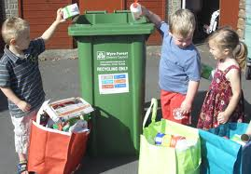

No = 

Yes = 

1. **Do you know what this symbol means?**

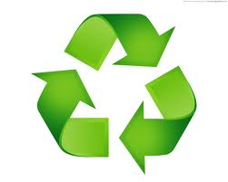

No = 

Yes = 

1. **Do you know why we recycle?**

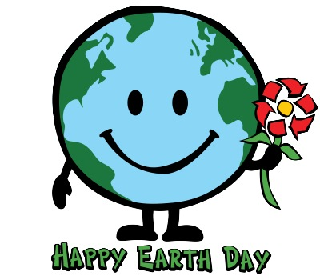

No = 

Yes = 

1. **Do you know what these bottles are made from?**

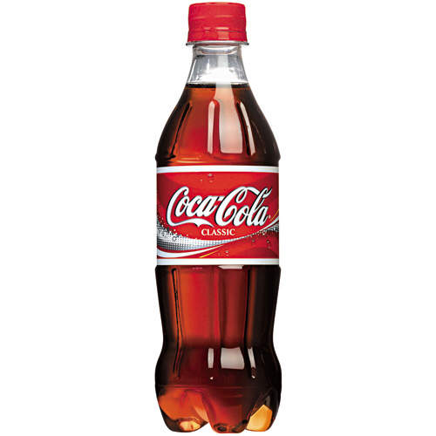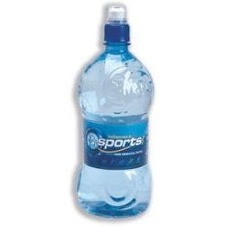

1. **Do you know what the little boy is doing?**

No = 

Yes = 

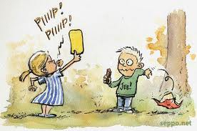

© Seppo Leinonen

No = 

Yes = 

1. **Is this litter?**



1. **Is littering bad? And why?**

No = 

Yes = 

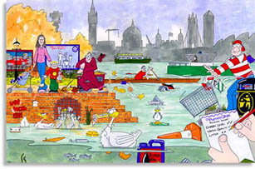

1. **Can we do anything to stop littering?**

No = 

Yes = 

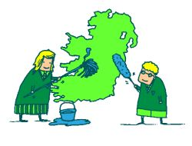

**Images:**

Image 1 – The recycle word available from <http://alcoa.typepad.com/recycling/2010/06/recycle-guys-reach-out-to-nc-school-children.html>

Image 2 – The children recycling from <http://www.thekiddiesdaynursery.co.uk/2010/07/09/eco-friendly-collection-day-today/>

Image 3 – The Mobius recycling symbol from <http://dddigitalcolour.com/recyclig/green-recycling-symbol/>

Image 4 – The Earth Day image from <http://www.twincitieslist.com/events/celebrate-earth-day-at-totally-kids/>

Image 5 – Coke and Water Bottle from <http://www.ballygowan.ie/additional-services.html> and <http://www.coca-cola.ie/>

Image 6 – A child littering from <http://www.seppo.net/cartoons/displayimage.php?pid=1037> (permission given to use in a non commercial manner)

Image 7 – Cartoon image of person with 2 bins from <http://www.greenschoolsireland.org/case-studies/litter-and-waste.220.html>

Image 8 – Drawing of impacts of littering from <http://marine-litter.gpa.unep.org/kids/kids.htm>

Image 9 – Cartoon image of people cleaning Ireland from <http://www.greenschoolsireland.org/resources/litter-and-waste.429.html>