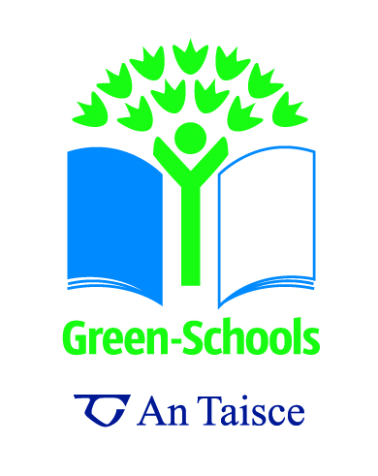

Recycling Quiz!
How much do you know about recycling?

- Which of the following cannot be recycled?
A. Milk cartons
B. Plastic water bottles
C. Glass jars
D. Paper bags
E. None of the Above

- Who can recycle?
A. Your teachers
B. Everyone
C. Your best friend
D. You
E. Your mom

- If you recycle one ton of paper, how many trees can you save?
A. One
B. Nine
C. Seventeen
D. Thirty-five
E. One Hundred

- How many times can glass be recycled?
- None, glass can’t be recycled!
- B. Once
- Four times
- Twenty times
- Forever

- The average aluminium can is made up of how much recycled aluminium?
A. 10%
B. 30%
C. 50%
D. 70%
E. 100%
6. What ways can you help save our earth?
A. Re-use your plastic bottles and bags
B. Reduce the amount of waste you produce
C. Plant a tree
D. Recycle
E. All of the Above!

7. What item should never go into the recycling bin?
A. Batteries
B. Paper
C. Cardboard
E. Plastic Bags
F. All of the Above

8. Recycling just one plastic bottle will save enough energy to power a 60 watt light bulb for how long?
A. 10 minutes
B. 30 minutes
C. One hour
D. Three hours
E. There won’t be enough energy.

9. How much oil does recycling one tonne of plastic save compared to making new plastic?
A. 100
B. 560
C. 1000
D. 1500
E. 2600

10. Which of these can the school collect in aid of charitable organisations?
A. Stamps
B. Mobile Phones
C. Clothes
D. Computers
E. All of the Above

Answer Key

- Which of the following cannot be recycled?
A. Milk cartons
B. Plastic water bottles
C. Glass containers
D. Paper bags
E. None of the Above – That’s right, all of these items listed can and should be recycled!

- Who can recycle?
A. Your teachers
B. Everyone – So sort through your garbage and head to the recycling centre!
C. Your best friend
D. You
E. Your mom

- If you recycle one ton of paper, how many trees can you save?
A. One
B. Nine
C. Seventeen – Studies have proven that one ton of paper is equivalent to seventeen fully grown trees.
D. Thirty-five
E. One Hundred

- How many times can glass be recycled?
A. None, glass can’t be recycled!
B. Once
C. Four times
D. Twenty times
E. Forever - that’s the amazing thing about glass, it never wears out!

- The average aluminium can is made up of how much recycled aluminium?
A. 10%
B. 30%
C. 50% - Last year alone, the 36 billion aluminium cans landfilled had a scrap value of more than $600 million. If we don’t recycle them, someday we’ll be mining our landfills for the resources we’re burying.
D. 70%
E. 100%

6. What ways can you help save our earth?
A. Re-use your plastic bottles and bags
B. Reduce the amount of waste you produce
C. Plant a tree
D. Recycle
E. All of the Above! – By taking these small steps, you can help preserve our Earth’s natural beauty.

- What item should never go into the recycling bin?
A. Batteries – Batteries must be disposed of correctly and not in the recycling bin!
B. Paper
C. Cardboard
D. Plastic Bags
E. All of the Above

- Recycling just one plastic bottle will save enough energy to power a 60 watt light bulb for how long?
A. 10 minutes
B. 30 minutes
C. One hour
D. Three hours – that is a lot of energy to save!
E. There won’t be enough energy.

- How much oil does recycling one tonne of plastic save compared to making new plastic?
A. 100
B. 560
C. 1000
D. 1500
E. 2600 - Wow that is a lot of oil to save!

- Which of these can the school collect in aid of charitable organisations?
A. Stamps
B. Mobile Phones
C. Clothes
D. Computers
E. All of the Above – Organisations such as the Jack and Jill Foundation, IPCC, would be grateful for your schools collections!

