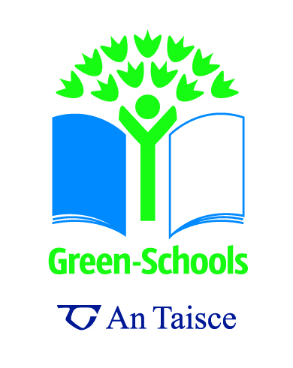 Questionnaires and Surveys
Questionnaires and surveys are great ways of gathering information about people’s habits, knowledge, opinions and preferences. A questionnaire is a great tool to use as part of your Environmental Review. You can also redo the questionnaire throughout your work on the Green-Schools programme as a method of Monitoring and Evaluation (Step 4). Here are some tips to creating a great questionnaire!

- Determine what it is you want to find out. For example, are you interested in people’s attitudes to recycling, levels of recycling in the school or at home, do pupils think the school has a litter problem, etc.
- Decide who you are going to distribute the questionnaire to. For example, pupils and students, teachers, parents, local businesses, the local community, etc.
- Create an introduction for your questionnaire that outlines why you are conducting the questionnaire and instructions on how to complete it.
- Decide how you are going to distribute and collect the questionnaire, for example by post, email, sent home with students, etc.
- Collate the results of the questionnaire and create graphs and pictures to show the results. Display the results on your notice board so the whole school body can see.

Seven Steps Links:

Step 2: Environmental Review | Questionnaires and surveys are great ways of assessing the initial situation in the school as regards litter and waste.
Step 3: Action Plan | The results of the questionnaire will allow you to identify what kind of actions you will need to tackle litter, increase recycling, etc
Step 4: Monitoring and Evaluation | By redoing the questionnaire at a later point of your Green-Schools programme you will be able to recognise how successful the programme has been.
Step 5: Curriculum Work | Maths, Art and IT classes may be able to create graphs and diagrams that show the results of the questionnaire.
Step 6: Informing and Involving | Questionnaires are great way of informing and involving the school body and wider community and increasing awareness of Litter and Waste issues.
Sample Questionnaire

We are students from ______________and we are conducting a questionnaire to find out about recycling in our homes as part of our work on the Green-Schools programme. If you could take a few minutes to complete the questionnaire we would be very grateful. Thank you for your time.

- What is recycling?

- What materials do you recycle?
Plastic
Paper
Cardboard
Cans
Bottles
Other ____________________________________________________________

- How long have you been recycling?
Days
Weeks
Months
Years

- Why do you recycle?
To help the environment
For fun
To save money
Other ________

- If you don’t recycle, why not?

- If you don’t recycle, will you start?

- Do you know where your local recycling centre is?
Yes
No
If yes, where? ______________________________________________

- When you grow out of clothes do you:
Throw them out and buy something new
Pass them on to a sibling of friend
Donate them to a charity

- What do you do with paper that is printed on one side?
Use the other side
Throw it in the rubbish bin
Recycle it

- Do you compost at home?
Yes
No

- If not, why not?

Recycling Facts

Why should we recycle?
Recycling conserves our valuable natural resources! Recycling helps to conserve our natural resources such as oil, metal and water. For example plastic bottles can be recycled into new plastic bottles and polyester fibres for use in fleece jumpers and car mats. By recycling we reduce the amount of natural resources needed to make products and packaging. Also less mining and extraction occurs, which is beneficial to the natural habitats of wild animals.

Recycling saves energy!
Recycling aluminium saves 95% of the energy required to produce aluminium from raw materials. Recycling just one plastic bottle will save enough energy to power a 60 watt light bulb for 3 hours!

Recycling protects the environment!
Recycling helps to conserve energy, so less greenhouse gases are emitted. Recycling reduces our dependence on landfill. With less materials going to landfill, less harmful emissions like methane gas are released into the earth's atmosphere.

Recycling can save you money!
By putting more recyclable materials into your recycling bin you reduce the amount of times you have to put your general refuse or black bin out for collection. It is usually more expensive to collect the black bin than the recycling bin, so recycling can save you money!

(Recycle facts adapted from www.recyclemore.ie )
Top Tip! If you have any blank space left on your questionnaire why not include some tips on recycling as a way of Informing and Involving!

