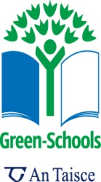
The Japanese Spider crab is the largest crab in the world, measuring a massive average 4m in length and taller than any human!
Crabs
Crabs are hard shelled animals found on land, in rivers and in the sea. These 10 legged animals have two legs modified into claws. Their outer shell is called an exoskeleton, and crabs shed and re-grow this as they get bigger! They are in the group of animals known as crustaceans, along with prawns and lobsters. Crabs are not fussy eaters! They eat plankton, seaweed, shellfish, fish, a whale carcass- basically anything, dead or alive!
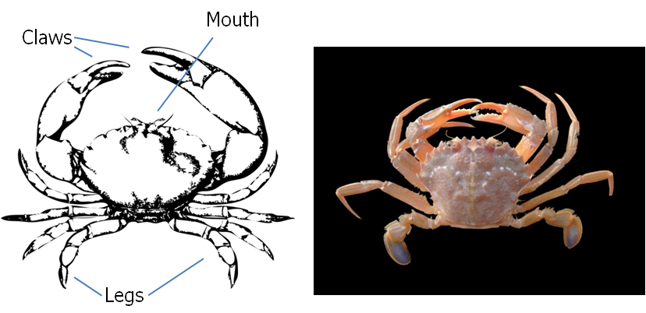
Some crabs are walkers and some are swimmers. The diagram on the left above shows a swimmer crab (pointed back legs for gripping rocks and sand) while the crab on the right is a swimming crab (oar shaped back legs to aid movement in the water). You can tell a male crab from a female by turning them upside down- a female has a U shaped abdomen while males have a V shape.
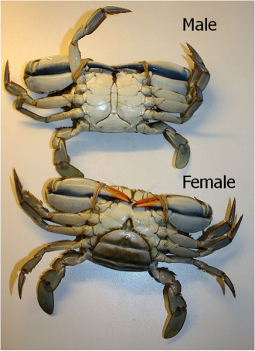
Actions:
- Crabs come in almost all colours and sizes. Use your imagination and create your own species!
- Research other crustaceans such as lobsters, prawns or sea spiders
- What animals eat crabs? Create a food chain using crabs

