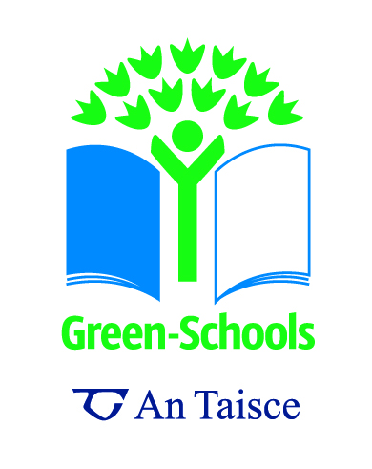
The Life of a Plastic Bottle Part 4

Concept / Topic To Teach: to help students understand the serious issues associated with litter and waste and the resources required to create the items we use & dispose every day. To look at our own impact on the environment.

Target audience: Senior Secondary school students.

Related workshop / Step: Environmental Review; Action Plan; & Informing & Involving

General Goal(s): To put it into context why waste is such a problem and to get students to think about our ‘disposable’ society. To get students to identify, discuss and implement simple strategies for improving and caring for the environment.

Specific Objectives: To develop ownership for everything we use in our daily lives from ‘cradle to grave’.
To get students to think along the principles of REDUCTION at source - do we need things in the first place? What happens to our waste?
To Work Scientifically – Questioning, Observing, Predicting, Investigating & Experimenting, Estimating & Measuring, Analysing, Recording and Communicating.
Seven Step Link: All

Required Materials: a plastic bottle

Preparation Level: Low

Students’ pre-requisite knowledge and skills: awareness of the global environmental problems & the origin of materials we use.

Anticipatory Set (Lead-In): Review with the students the origin of plastic and discuss how much plastic we use in our daily lives.
Discuss where this plastic goes – landfill, incineration, recycling.
See how many students in the class have plastic drinking bottles.

2.4 millIon tonnes of plastic are used to bottle water each year which represents massive oil use for what is essentially a single-use object. To make the 29 billon plastic bottles used annually in the US, the world's biggest consumer of bottled water, requires more than 17 million barrels of oil a year, enough to fuel more than a million cars for a year.
It takes 162g of oil and seven litres of water (including power plant cooling water) just to manufacture a one-litre bottle, creating over 100g of greenhouse gas emissions (10 balloons full of CO2) per empty bottle.
Give each group this information to discuss & investigate further.

Step-By-Step Procedures:
Encourage debate & investigation into the life cycle of the plastic bottle; the use of our natural resources; the management of waste in Ireland.
Investigate their own use of plastic bottles, and that in the school: look at how many bottles are present in the classroom and estimate how many are in the school, how many are used per day / week / month etc and create a visual representation of this.
Encourage a visit to or from the school’s waste management service provider and create an interview forum with questions from the students about the topic.
Instigate a reuse & recycle plastic bottle campaign within the school.
Look in more detail at the formation of fossil fuels and specifically our use of oil.
Cradle to Grave ownership – where our plastic waste goes.
Investigations into the buildup of unwanted plastics in third world countries and the eastern pacific garbage patch.

Closure: Produce the graph plastic waste created in the school and display. Set reduction targets and explain to all students what the campaign is about.
Display the life cycle of plastic, if it gets recycled, or if it ends up in landfill.
Encourage essay writing / plays / art competitions on the topic.

Adaptations for students with learning difficulties:
This is a very visual and tactile exercise and the children can touch and feel the wet paper breaking down, but the bottle stays the same. Balloons are also a very good visual aid for the CO2 emitted per bottle.
Extensions (for gifted students)
Investigate other materials that will be available to replace plastic – Young Scientist of Young Social Innovator Project.
Links to other subjects
Geography, Chemistry, Biology, Physics, Engineering, and SPHE.
- Properties and characteristics of materials
- Observe and investigate a range of familiar materials in the immediate environment
- Describe and compare materials noting the differences in the colour, shape and texture
- Know about some everyday uses of common materials
- Group materials according to certain criteria
- Environmental Awareness and Care - Identify, discuss and implement simple strategies for improving and caring for the environment
- Working Scientifically Skills - Questioning, Observing, Predicting, Investigating & Experimenting, Estimating & Measuring, Analysing, Recording and Communicating
- Design & Making Skills

