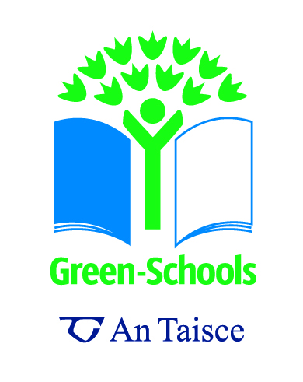
The Hoola Hoop Game (Waste Sorting)

Concept / Topic to Teach: the different properties & characteristics of materials; and Environmental Awareness and Care

Target audience: Junior Primary school students

Related workshop / game: Life of a plastic bottle Workshop; Juice Carton Graph

General Goal(s): to help children understand why we should reduce, reuse, and recycle it where possible. Identify, discuss and implement simple strategies for improving and caring for the environment.

Specific Objectives: To develop ownership for everything we use in our daily lives from ‘cradle to grave’.
To get students to think along the principles of REDUCTION at source - do we need things in the first place? What happens to our waste?
To Work Scientifically – Questioning, Observing, Predicting, Investigating & Experimenting, Estimating & Measuring, Analysing, Recording and Communicating.

Seven Step Link: All

Required Materials:
- 2 hoola hoops with labels one for Paper & one for Plastic.
- A newspaper, magazine, takeaway menu, toy catalogue, yogurt pot, cling film, foil wrapper from lunch time snacks, variety of plastic drink containers and bottles.
- A bin or bucket to hold the waste.

Preparation Level: Medium

Students’ pre-requisite knowledge and skills: It helps if the school is already recycling and has clear colour coded or labelled bins for waste segregation.

Anticipatory Set (Lead-In): Ask the following questions:

What is rubbish?
Where does our rubbish go once we have put it in the bin? Show students a picture of a landfill site.

Step-By-Step Procedures:

We are going to help save Mr Plastic bottle and Miss Newspaper from ending up in the landfill! Our job is to sort our bin (bin full of items on the equipment list) and separate all the plastic and paper items.

Sit students in a circle with two hoops in the middle. Ask volunteers to reach into the bin and to place the item in the correct hoop.

Discuss the differences between paper and plastic:
Can you tear plastic or paper?

What happens when plastic and paper gets wet? (you can demonstrate this after the discussion)
Which one do you think will break into smaller pieces at the rubbish dump the quickest?

Discuss ways you could reuse the paper and plastic items in the hoops.
Talk about what they could have been made into, if you have time you can actually make things out of them, especially the newspaper.
Give each child a sheet of newspaper to draw on, make something out of for 10 minutes – they can make hats, handbags, sail boats, snakes out of a newspaper.
Plastic bottles can have things stuck onto them – glitter, paper etc or they can talk about the different toys they have made out of plastic and give examples.

Closure: Create a classroom waste chart of the different types of waste and monitor the waste generated by the children for one day or one week, placing a dot next to the item on the chart. Ask the children to guess which waste will have the most number of dots? Which waste will have the least number of dots? The dots will be a great visual representation for sorting data in terms of ‘more or less than’.
Do you think if we reuse items like we can reuse our drink bottles and paper there will be less rubbish in bin?
Adaptations for students with learning difficulties:
State what you would have to change to make the activity accessible for students with (the more common) learning difficulties.

Extensions (for gifted students)
Have something “up your sleeve” for those who finish quickly or find the lesson easy.

Links to other subjects
List links to other curricular areas. All of the National Primary Curricula are described in detail on the Department of Education website.

