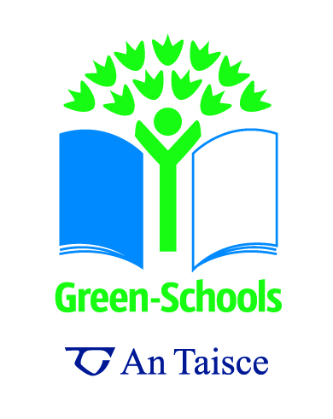
Energy Chains
Junior primary version

Concept / Topic to Teach: That all energy derives from the sun
Target audience: 5-10 year olds
General Goal(s): To get students to physically represent the energy flows on our planet.

Specific Objectives: To get students thinking about where energy comes from and how it flows through living systems. The examples in this lesson are:
Sun – Wheat – Chicken – Egg – Person
Sun – Wild Oats – Mouse – Owl
Sun – Plankton – Shrimp – Mackerel – Dolphin
Sun – Grasses – Greenfly– Ladybird – Blackbird
Sun – Ancient forests – Oil – Oil well – Car – CO2
Required Materials:
1 Sun mask/hat/large picture
Pictures of each of the things listed above on cards that can be attached to childrens’ clothes
Blackboard and chalk (optional)
String to make a string bracelet

Students’ pre-requisite knowledge and skills: Students need to be familiar with the species in the pictures. (With younger groups you don’t need to use all the sets.)

Seven-Steps link:
Curricular Work
Can inform Environmental Review and Action Plan
Informing and Involving- Helps younger children understand the Energy Theme
Anticipatory Set (Lead-In): Ask students to wave their hands/do a dance etc
Ask them “Where did you get the energy to do that? “ (from food)
What did you eat? (e.g. porridge) “Where did the oats get the energy from? “ (the Sun) Do a few examples like this, linking energy back to the sun.
Discuss the fact that only plants can get their energy directly from the sun- animals have to eat plants or other animals that have eaten plants.

Step-By-Step Procedures:
- Get one child to be the sun
- This child hangs the sun picture around his/her neck and stands in the middle of a clear space in the room. Give this child the string bracelet to put around his/her wrist
- Give each child a picture of one of the organisms from the first four groups. (see list above)
- Ask the children “Who has a picture of something that gets energy directly from the sun?” Give each of those a piece of string and they go and stand with the “sun” and they hold onto one of the string’s on the sun’s bracelet and stretch it out. They hold their own string in the other hand.

- Then ask if anyone has a picture of something that gets energy from one of those things (i.e., eats it) Give them a piece of string and they go and stand by their plant and stretch the plant’s piece of string between them. Continue on in this way. You don’t need to give the last link in the chain any string- they just hold the other end of the previous child’s string
- Ask the students what happens to the energy as it goes through the chain (organisms use it to move, to keep warm, to grow, to reproduce etc ) What happens when the organisms die? Where does the energy go?
- Now give out the last set of pictures (Forest, Oil barrel, Oil Derrick, Car)
- You may need to explain how oil and other fossil fuels were formed- from the fossil remains of plants and animals that lived long long ago (75 million years ago and 150 million years ago- these were the two periods when most of our fossil fuels were formed) Ask “”Where did those ancients trees get their energy?” Explain that the energy was compressed by earthquakes, soil building up on top, heat and tectonic plate movements. The amount of fossil energy we use every year took about 450 years worth of sunlight to create.
- Ask the children how we get the energy out again (by burning the fuel). What happens to a lot of the energy (it is released as heat). What else is released by burning fossil fuels? (CO2)
- Get the children to make a chain with the oil pictures in the same way. Ask “What is the difference between the oil chain and the other energy chains? “ (the oil one uses the sun’s energy stored over millions of years, the others all use the sun’s energy as it arrives on Earth)
- Then continue the discussion about CO2, climate change, depending on the level of the students.
- To summarise, make the distinction between renewable sources of energy, that depend on current sunlight, and non-renewable, fossil sources of energy that are ancient sunlight
- You could ask the children to create a new energy chain showing how renewable energy is used. (e.g, the sun’s energy causes wind, captured by a turbine, which can make electricity, pump water or move machines (such as mills)

Closure:
As a follow-up you can make paper chains to represent the energy flows. Give each child a piece of coloured card approx 8” x 2” and get them to draw and/or write the name of their plant or animal on it. Then staple the strips together to make paper chains. These could be hung from the ceiling radiating out from the light, or hung on a wall or board radiating out from a sun. With younger groups, you may just want to represent one chain physically, then have all the children make chains at their desks using the organisms and food webs they are familiar with.
Variations:
If you don’t have the space to do this, you can use the blackboard- stick the sun in the middle and have the students stick their pictures to the board with blu-tak and draw lines to link the organisms to the sun and to each other.
Follow-up:
An interesting project following on from these activities would be to investigate local energy sources and energy flows before the electrification of the country and before the availability of cheap oil and diesel everywhere. This could tie in with SESE History studies- the history of energy in the local area. In most areas of Ireland, students could easily interview people who grew up using very little fossil fuel.

Links to other subjects
SESE Science- Energy and Forces Strand
SESE Science and Geography- Environmental Awareness and Care Strand.
Art and Craft- Making things Strand

